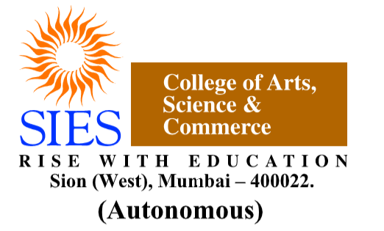

**SIES College of Arts, Science and Commerce (Autonomous)**

**Sion (W), Mumbai – 400 022.**

**Department of Information Technology**

**CERTIFICATE**

**This is to certify that Ms.SHAIKH AISHA ABDUL WAHEED of TYBSc [Information Technology], Semester VI, Seat No TIT2324064 has successfully completed the practicals and submitted it online in Microsoft Teams for the subject of ETHICAL HACKING as a partial fulfilment of the degree BSc(IT) during the academic year 2023-2024.**

**________________ _______________**

**Faculty-in-charge Internal Examiner**

**_______________**

**External Examiner**

**Date: College Seal**



**SIES College of Arts, Science and Commerce (Autonomous)**

**Sion (W), Mumbai – 400 022.**

**Department of Information Technology**

**CERTIFICATE**

**This is to certify that Ms.SHAIKH AISHA ABDUL WAHEED of TYBSc [Information Technology], Semester VI, Seat No TIT2324064 has successfully completed the practicals and submitted it online in Microsoft Teams for the subject of  DATA MINING as a partial fulfilment of the degree BSc(IT) during the academic year 2023-2024.**

**________________ _______________**

**Faculty-in-charge Internal Examiner**

**_______________**

**External Examiner**

**Date: College Seal**



**SIES College of Arts, Science and Commerce (Autonomous)**

**Sion (W), Mumbai – 400 022.**

**Department of Information Technology**

**CERTIFICATE**

**This is to certify that Ms.SHAIKH AISHA ABDUL WAHEED of TYBSc [Information Technology], Semester VI, Seat No TIT2324064 has successfully completed the practicals and submitted it online in Microsoft Teams for the subject of INTRODUCTION TO DATA SCIENCE as a partial fulfilment of the degree BSc(IT) during the academic year 2023-2024.**

**________________ _______________**

**Faculty-in-charge Internal Examiner**

**_______________**

**External Examiner**

**Date: College Seal**



**SIES College of Arts, Science and Commerce (Autonomous)**

**Sion (W), Mumbai – 400 022.**

**Department of Information Technology**

**CERTIFICATE**

**This is to certify that Ms.SHAIKH AISHA ABDUL WAHEED of TYBSc [Information Technology], Semester VI, Seat No TIT2324064 has successfully completed the practicals and submitted it online in Microsoft Teams for the subject of PRINCIPLES OF GEOGRAPHIC INFORMATION SYSTEM as a partial fulfilment of the degree BSc(IT) during the academic year 2023-2024.**

**________________ _______________**

**Faculty-in-charge Internal Examiner**

**_______________**

**External Examiner**

**Date: College Seal**